This is based on the roadside services provided by RACV (Royal Automobile Club of Victoria). Following criteria were used to select the features for the case study.
- Features offered by a real world application
- Representing all (most) the concepts of a feature model
- Different degree of complexity in the feature to ROAD mapping
  - 1:1, 1:n, m:1, and n:m
- Different degree of complexity in products
  - Number of features, tenants, services, roles, and interactions

Feature Model of the Roadside Assistance
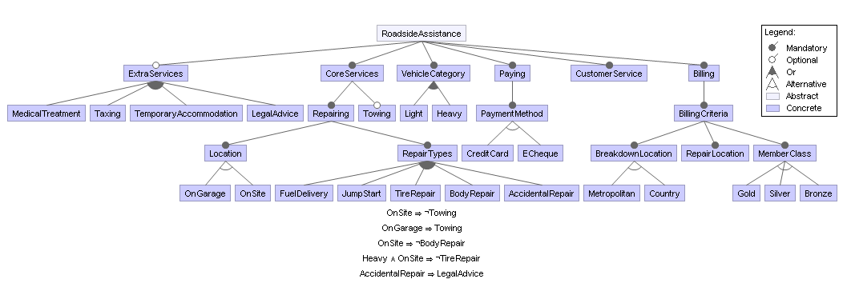

Overview of the Roadside Assistance Business Process

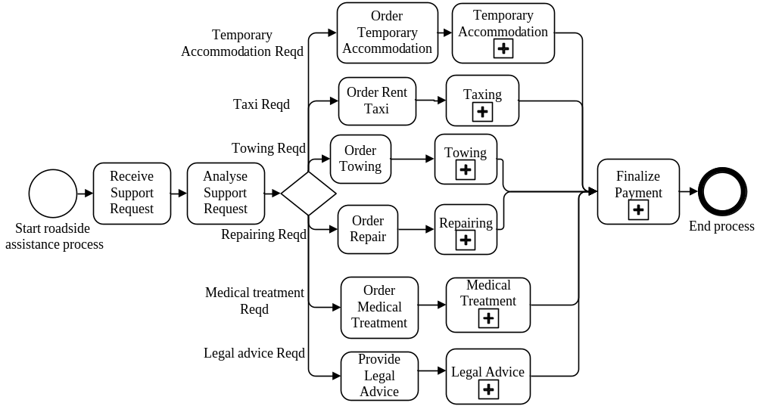

Repair Sub Process

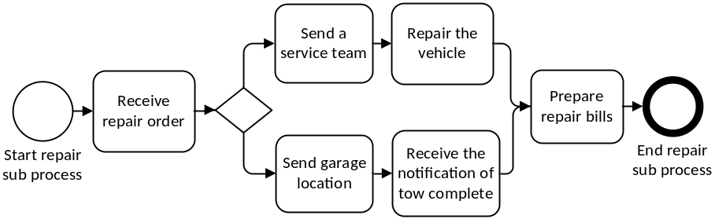

Towing Sub Process

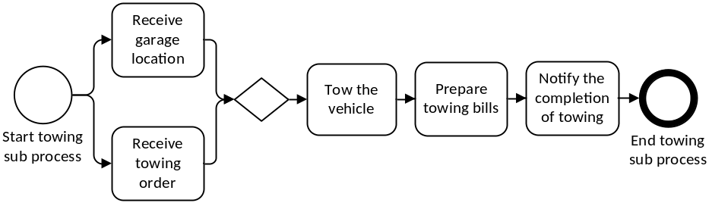

Taxing Sub Process
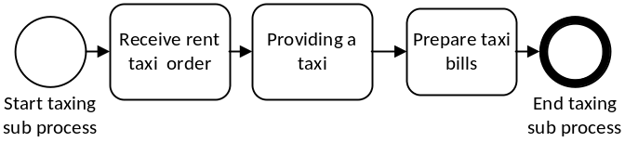

Temporary Accommodation Sub Process

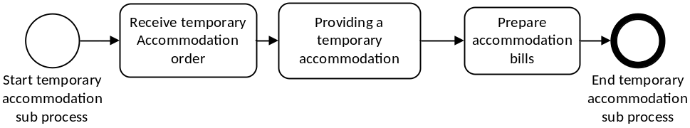

Medical Treatment Sub Process

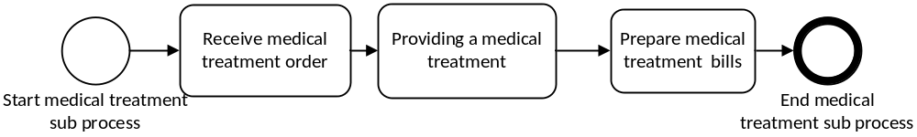

Legal Advice Sub Process

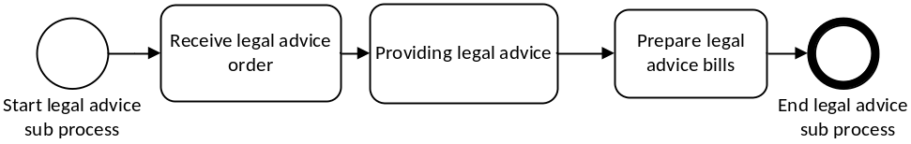

Payment Sub Process

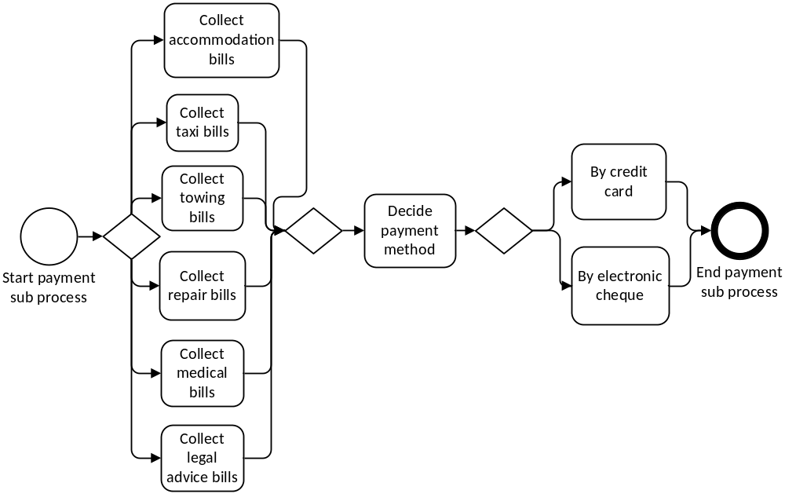

10 Product Variants

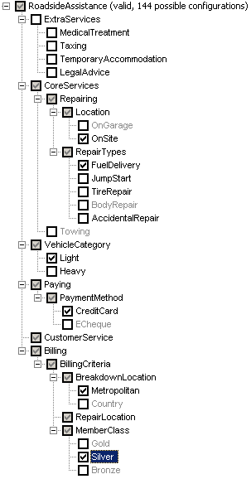
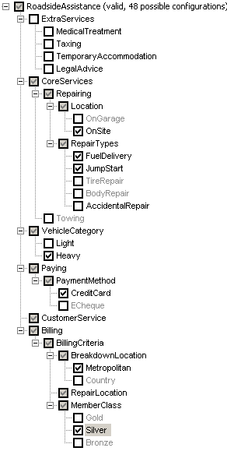

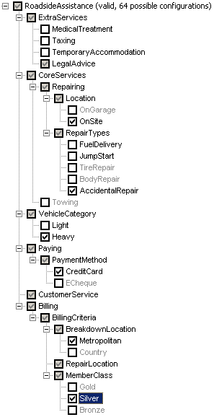
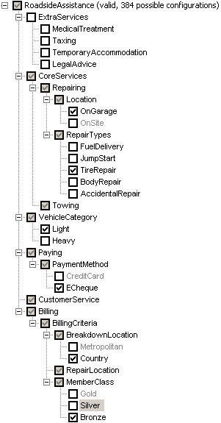

Product 3

Product 4

Product 5

Product 6

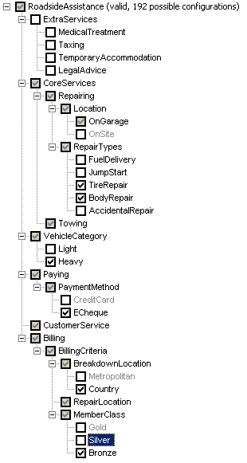
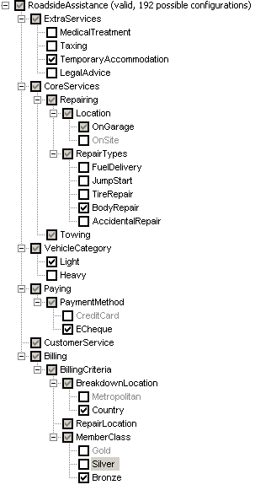
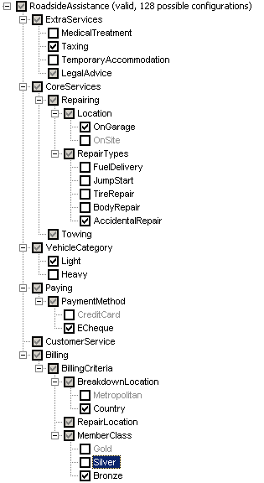
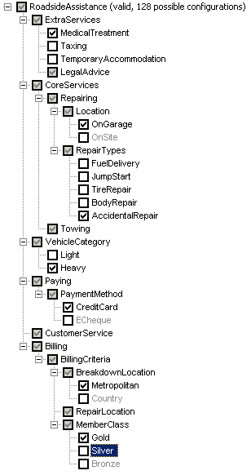
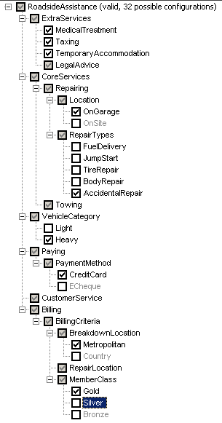

Product 10

http://www.racv.com.au/wps/wcm/connect/internet/primary/roadside+assistance

